Sponsorship  Form | 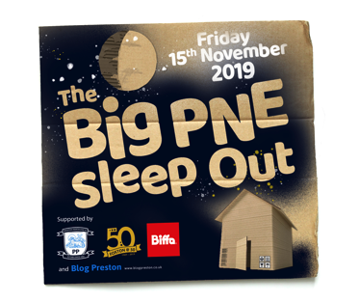

Event name The Big PNE Sleep Out
The BIG

Event date 15th November 2019 Name Address

Telephone
Email Total Giving Page

Full name (Please print) | Home address (Please print)  Rather than your work address (this is essential for Gift Aid) | Postcode | Donation Amount (£) | Date paid | Gift Aid?*  Please tick
Cheques should be made payable to THE FOXTON CENTRE 50 (PBSO). Once you have collected all your sponsorship donations, please return them as soon as possible together with this form to The Foxton Centre, Knowsley Street, Preston PR1 3SA.

The Foxton Centre is a registered charity (1153080) and further information can be found at www.thefoxtoncentre.co.uk
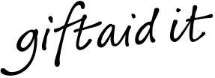
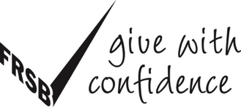
* By ticking the box you have agreed that you are a UK Income or Capital Gains taxpayer, and that you want The Foxton Centre to reclaim tax on your donation detailed, given on the date shown. You understand that you must pay an amount of Income Tax and/or Capital Gains Tax in the tax year at least equal to the amount of tax that all the charities and Community Amateur Sports Clubs you donate to, will reclaim on my gifts for that tax year. You understand that other taxes such as VAT and Council Tax do not qualify.
By adding Gift Aid to your donation, it means that for every £1 you give, the Inland Revenue will give The Foxton Centre an extra 25p and it doesn’t cost you a penny

