Furniture (F)

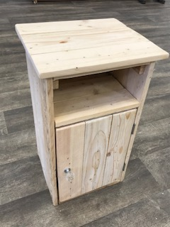 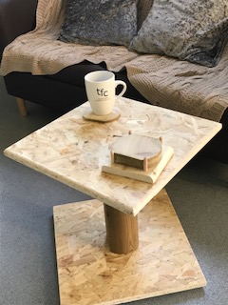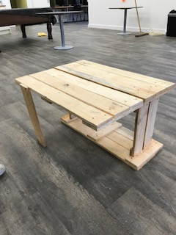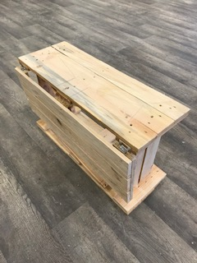

Half leaf table L80cmxH53cmxD33cm £20

(F003)

Cabinet H62cmxW37xD32cm £30

(F001)

Side Table H40cmx50cm2 top £20 (F002)

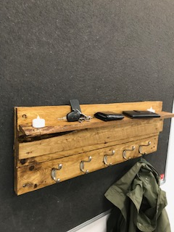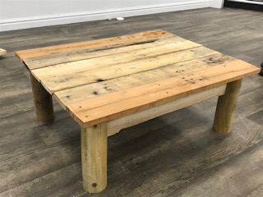 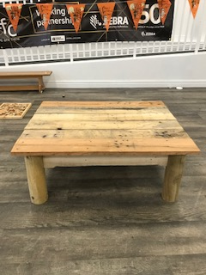

Table Large H40cmxL100cmW80cm£80

Table Medium H40cmxL70cmW70cm£50

(F005)

Coat Hook shelf 50cmx20cm £15

(F004)

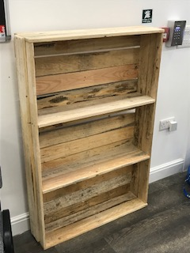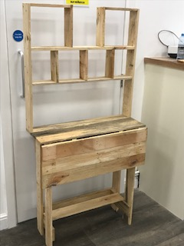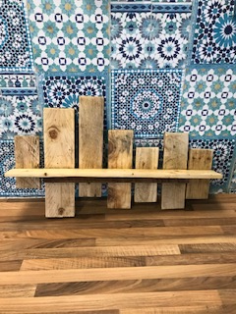

Shelf L75cm £15

(F008)

Wall unit H180cmxW100cm £30

(F007)

Book shelf H120cmxW80cm £25

(F006)

Indoor Furnishings (IF)

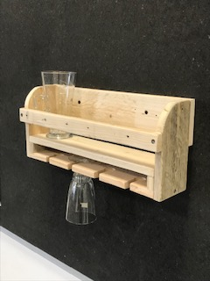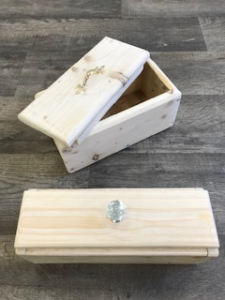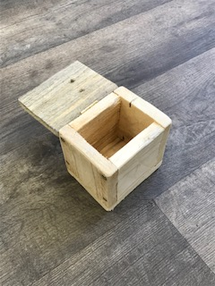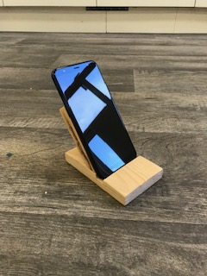

Phone / tablet holder £5

(IF004)

Trinket box 12cmx12cm £5

(IF003)

Small box 33cmx13cm £10-£15

(IF002)

Bottle / glass holder 44cmx15cm £20

(IF001)

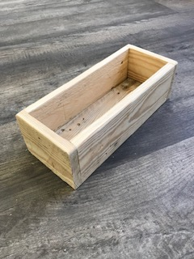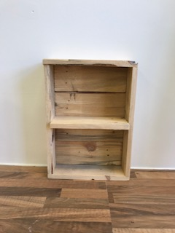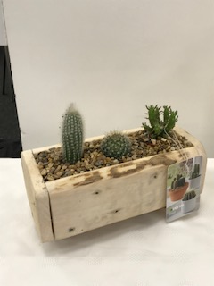 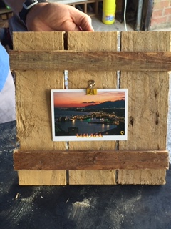

Picture Frame Square 30cm £6

(IF008)

Cactus planter (incl cactus) 32cmx10cm £15

(IF007)

Tray / shelf 40cmx30cm £15

(IF006)

Small holder 32cmx10cm £10

(IF005)

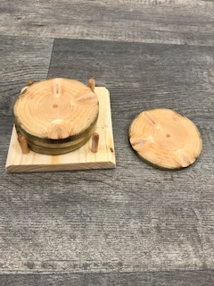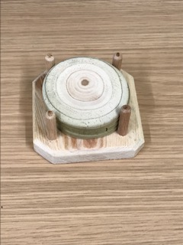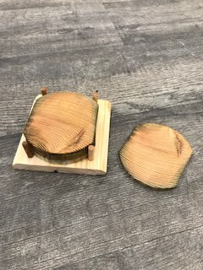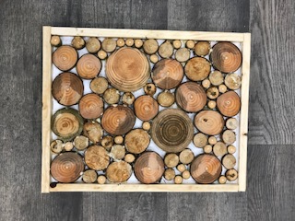

Decoration 46cmx36cm £10

(IF011)

Coasters set of 4

Small 7cm coaster £5 (IF009)

Large 10cm coaster £6 (IF010)

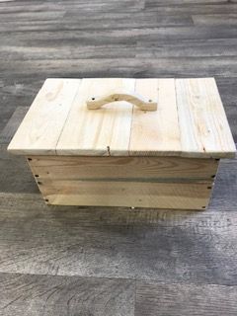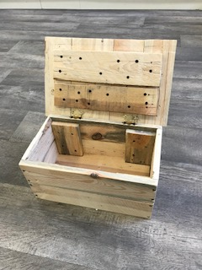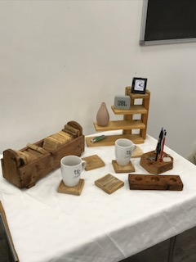

Small desk tidies £5

(IF013)

Small Chest 42cmx26cm £20

(IF012)

Outdoor (OU)

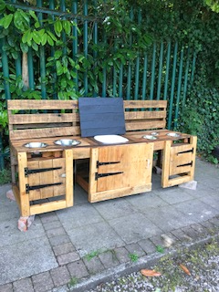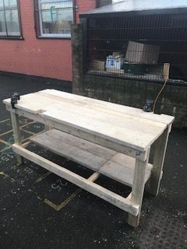

Work bench with 2 vices L200cmx H100cmxD100cm £150

(OU002)

Mud Kitchen

Sized and made to order from £100

(OU001)

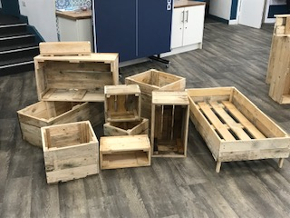 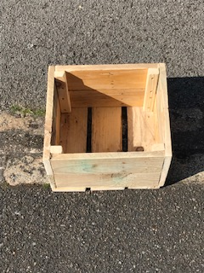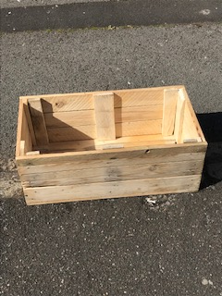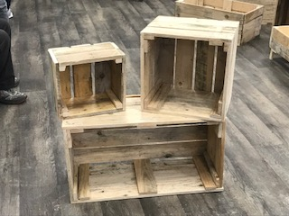

Planters

Small 30cmx20cm £10 (OU003)

Medium 30cmx30cm £15 (OU004)

Large 80cmx30cm £20 (OU005)

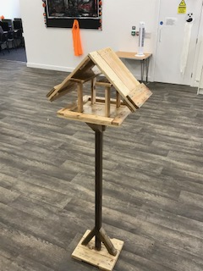 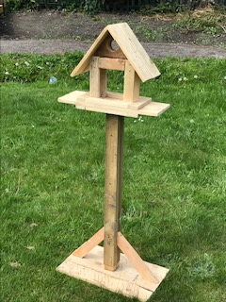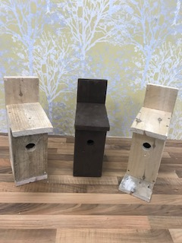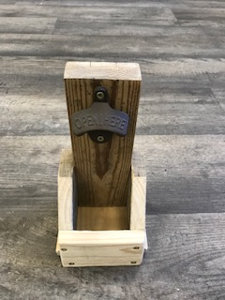

Bottle opener

H30cm £10

(OU008)

Bird Box 40cmx20cm £7.50 each

(OU007)

Bird Table Up to 160cm high £30

(OU006)

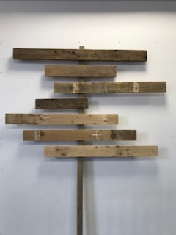 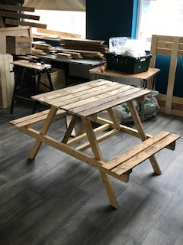 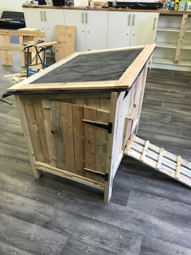

Chicken / Rabbit hutch Size to order from £100

(OU012)

Picnic Bench

Medium L100cmxH100cmxW120cm£50 (OU010)

Large L150cmxH100cmxW120cm£75 (OU011)

Sign 150cmx60cm £15

(OU009)

Christmas (CH)

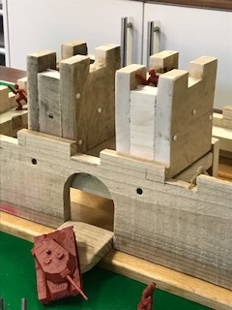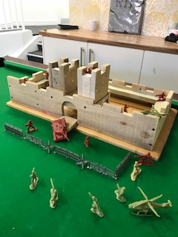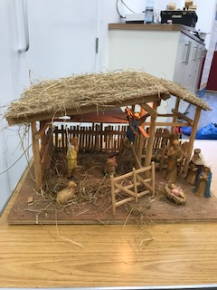

Crib £25 (without figures) (CH002)

Wooden Fort 72cmx42cm £50

Soldiers not included (CH001)

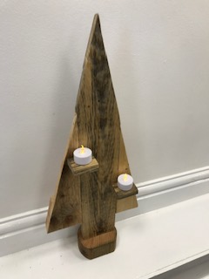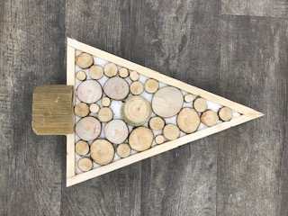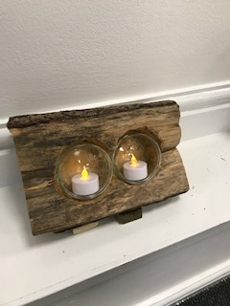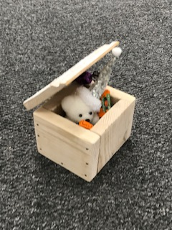

Gift box (with toy and sweets) £12.50

(CH006)

Tee light holder (with lights) £12

(CH005)

Decoration

H42cm £10

(CH004)

Decoration

H42cm £10 (with lights) (CH003)

The majority of each item is made from recycled wooden pallets and re-purposed to help reduce the amount going into landfill

All product sizes are approximate indications. Bespoke items can be requested and made to order. All items can be painted or stained to own choice upon request.

**07843088089**

**Peter.ashton@thefoxtoncentre.co.uk**

**/TheFoxtonCentre**

**@TheFoxtonCentre**

**Knowsley Street, Avenham**

**Preston**

**PR1 3SA**

**Telephone:**

**email:**

**Facebook:**

**Twitter:**

**Address:**